September 29, 2024

CMs ID: 023-23-0365

Submitted to: Ma’am Marina

Sukkur IBA University

DSA lab 05 Solution

Faheem Akbar

1. Print in reverse order: You are asked to design a method in linked list to print data in reverse order. You don’t need to reverse linked list permanently.

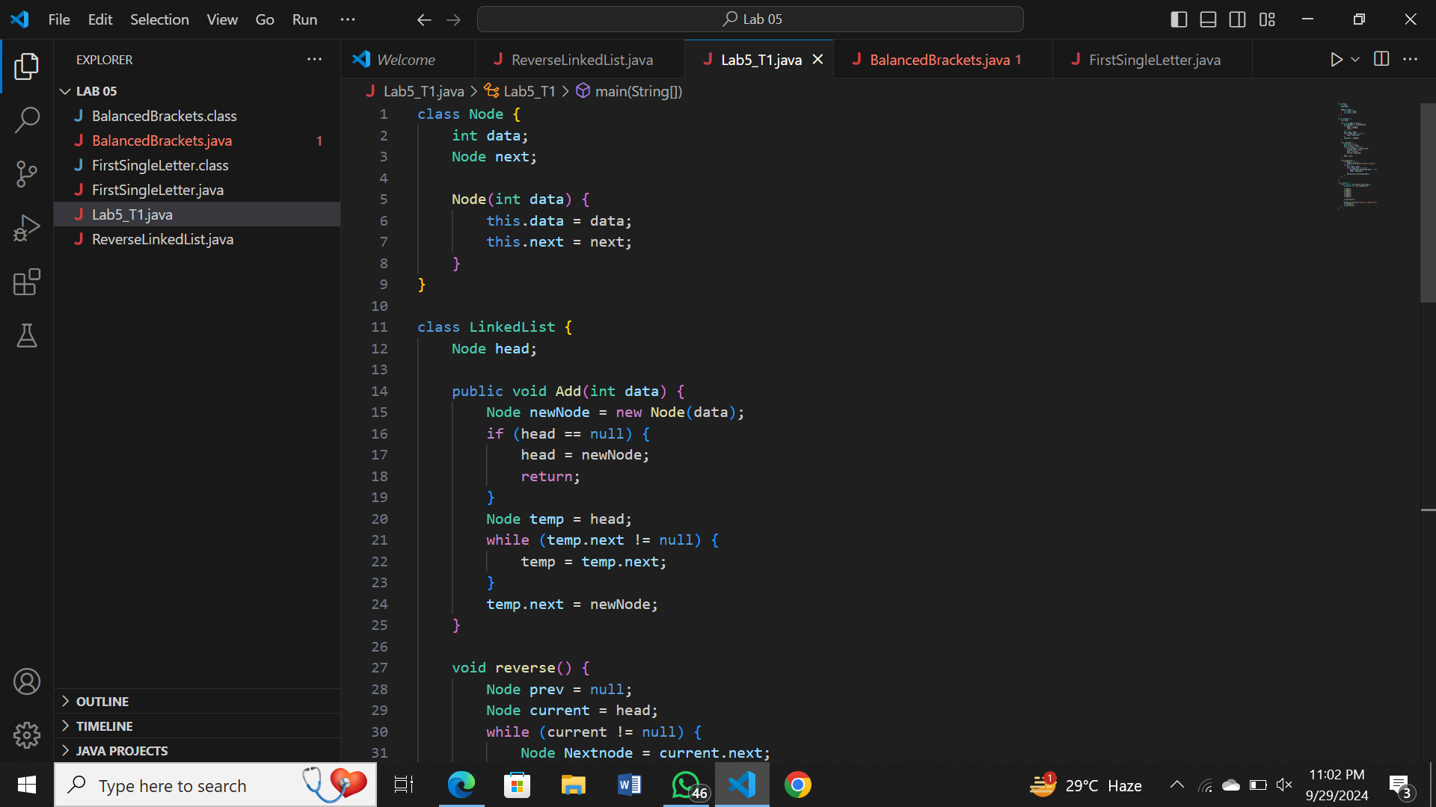

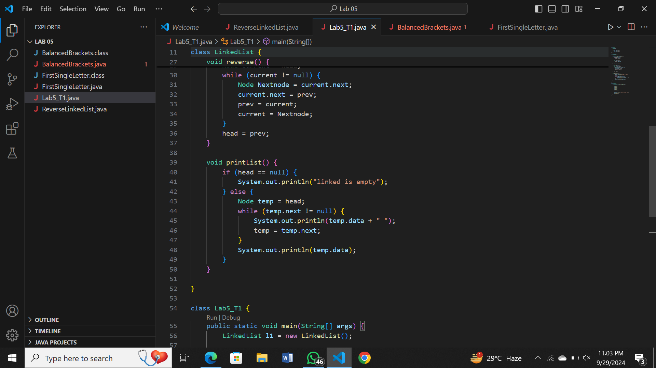

Output:

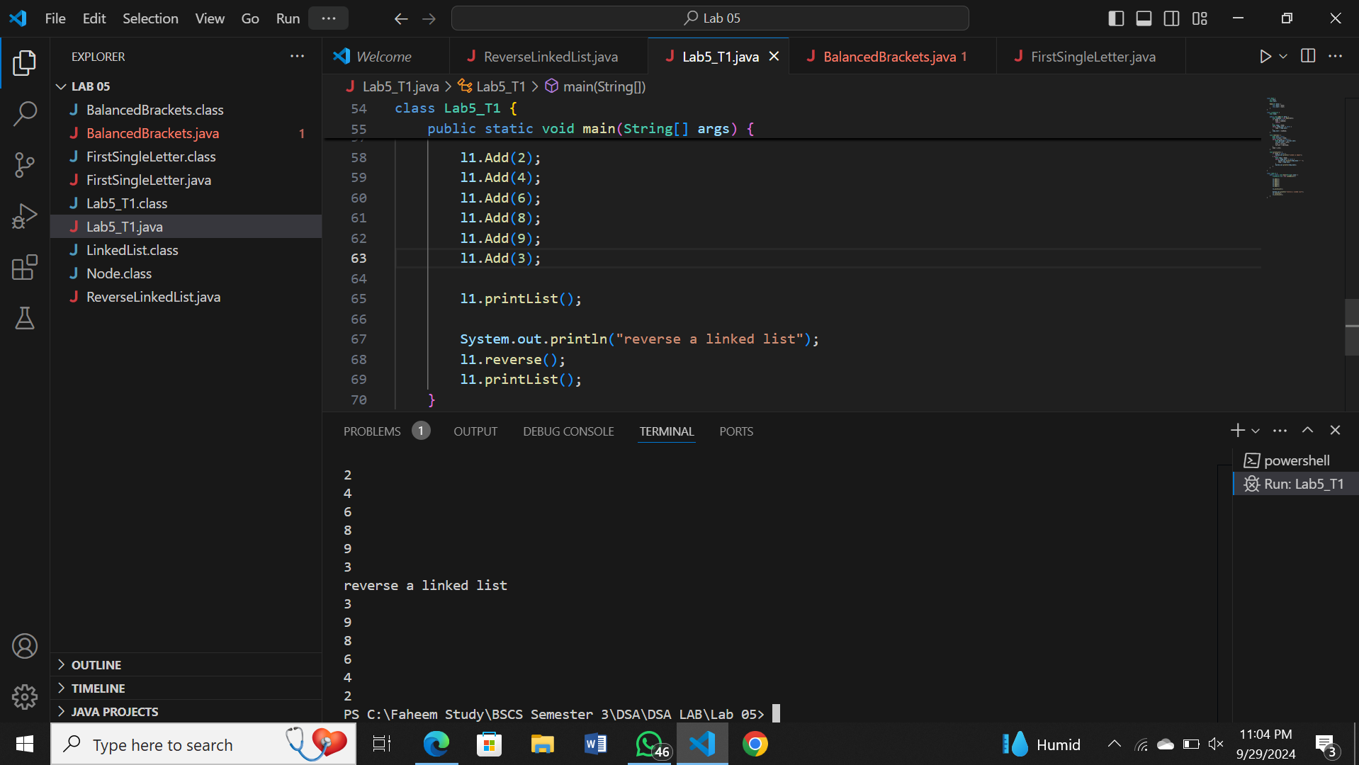

1. Balanced Brackets: Take user string input and check whether it’s balanced or not. Use stack functions. Input may contain any of the bracket among {, [, ( and any number and letters like: ({[a+b]+c}-1) and so on

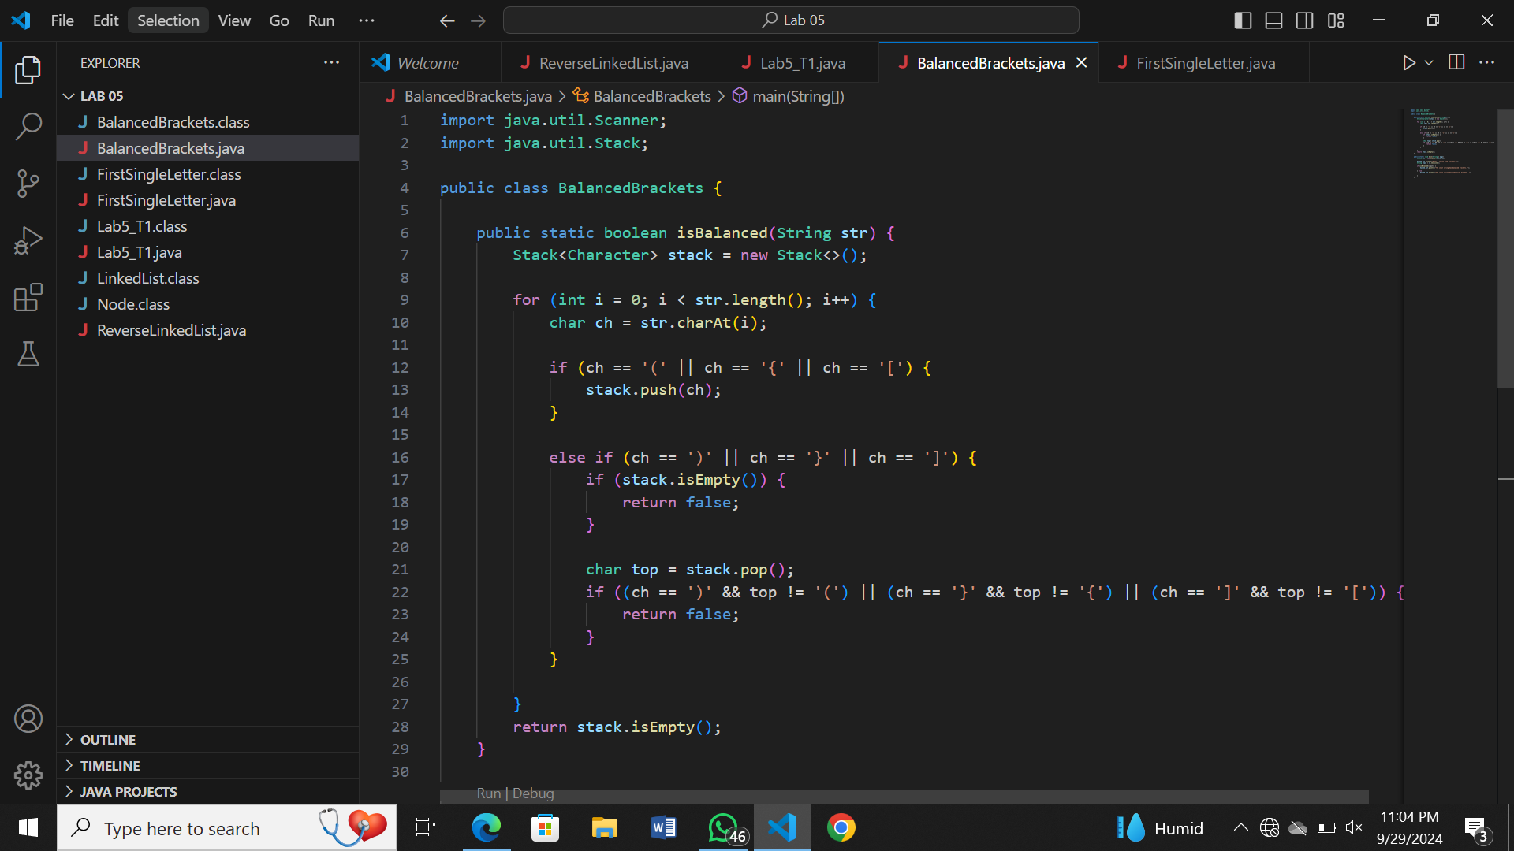

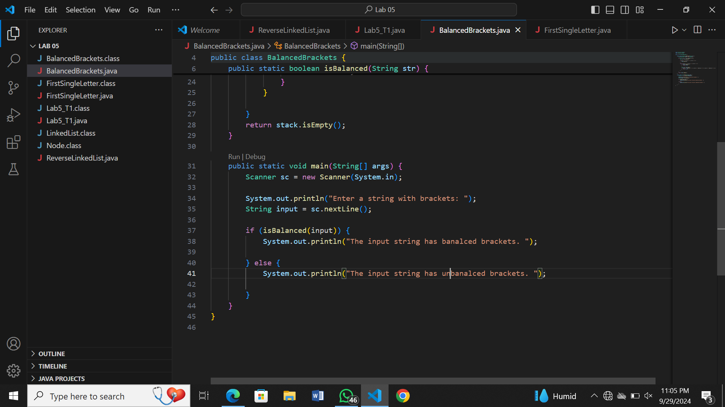

Output:

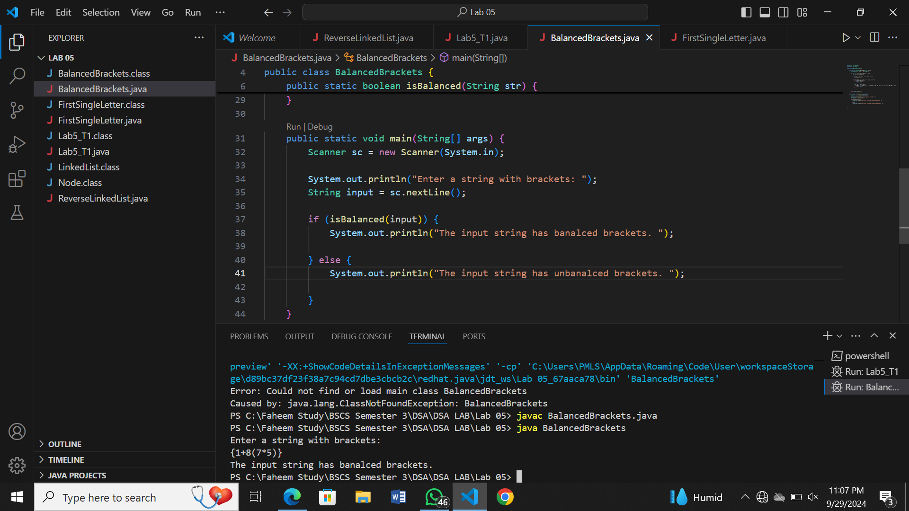

1. FirstSingleLetter: Create the function char firstSingleLetter (const char text [], const int n) which finds and returns the first letter of text that occurs only once. n is the number of characters in the text

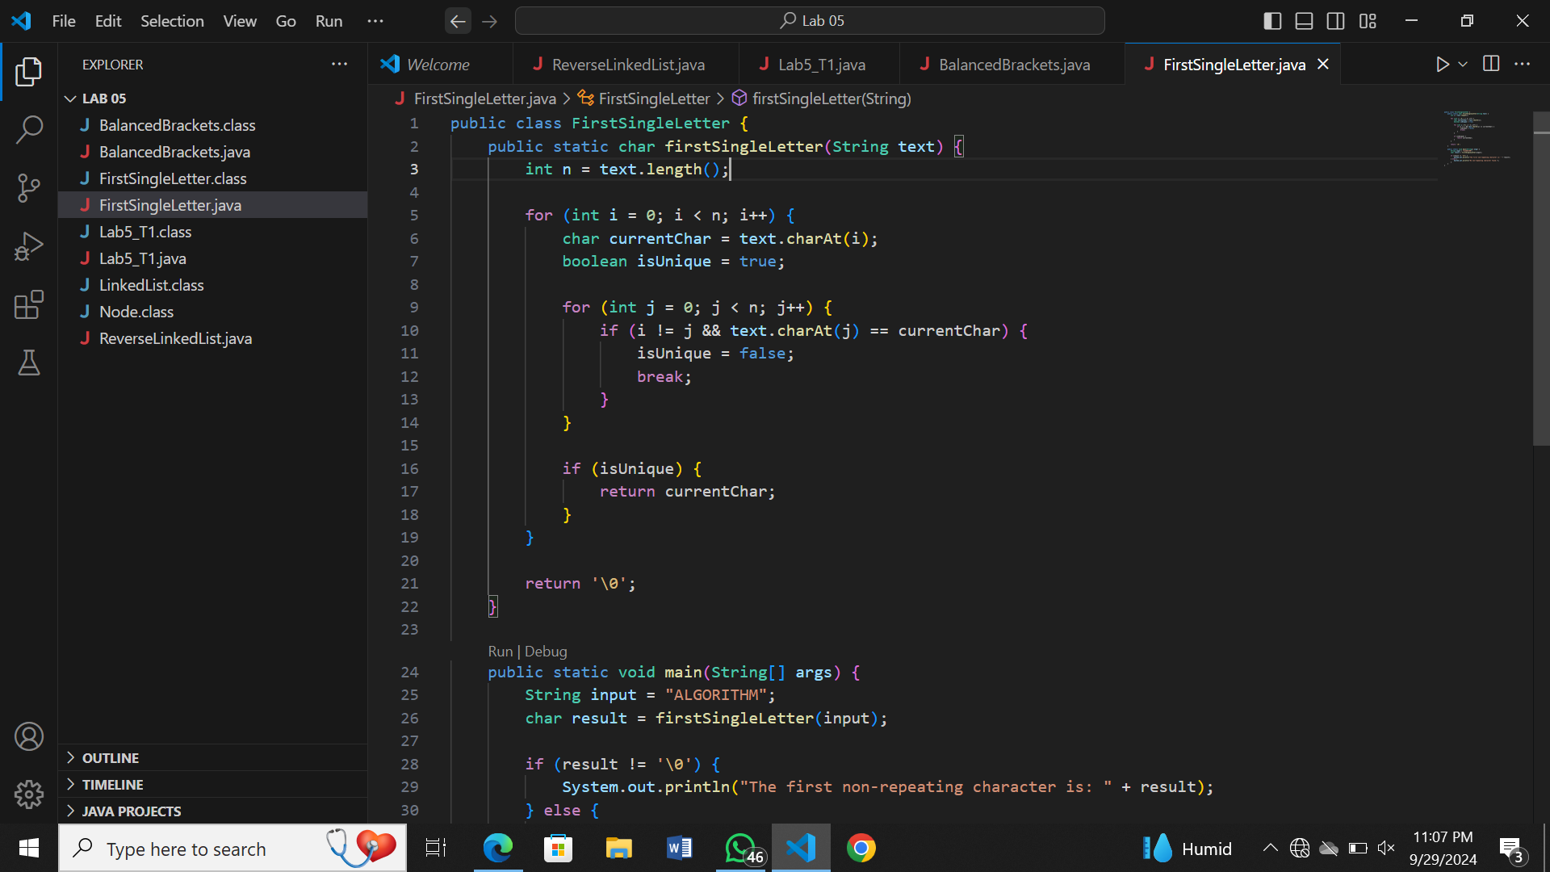

Output:

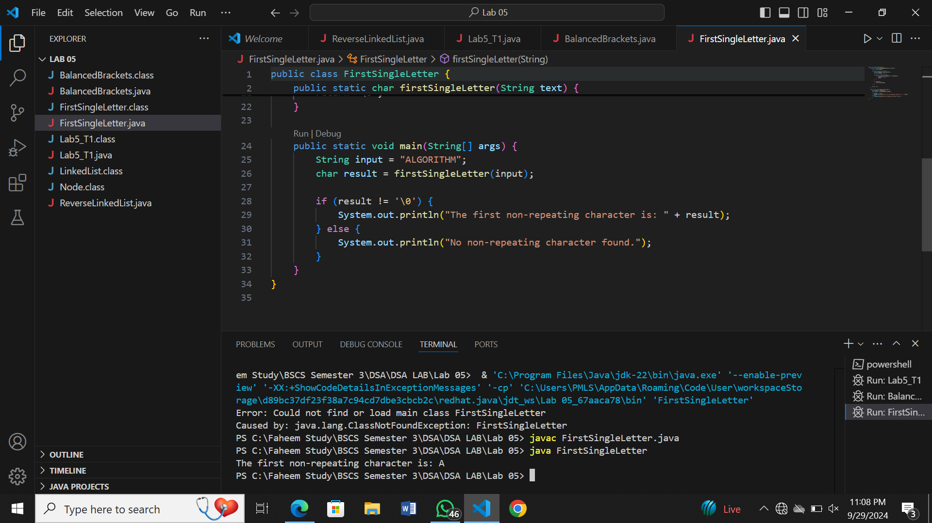

1. Convert Infix expression to Postfix expression using Stack data structure.

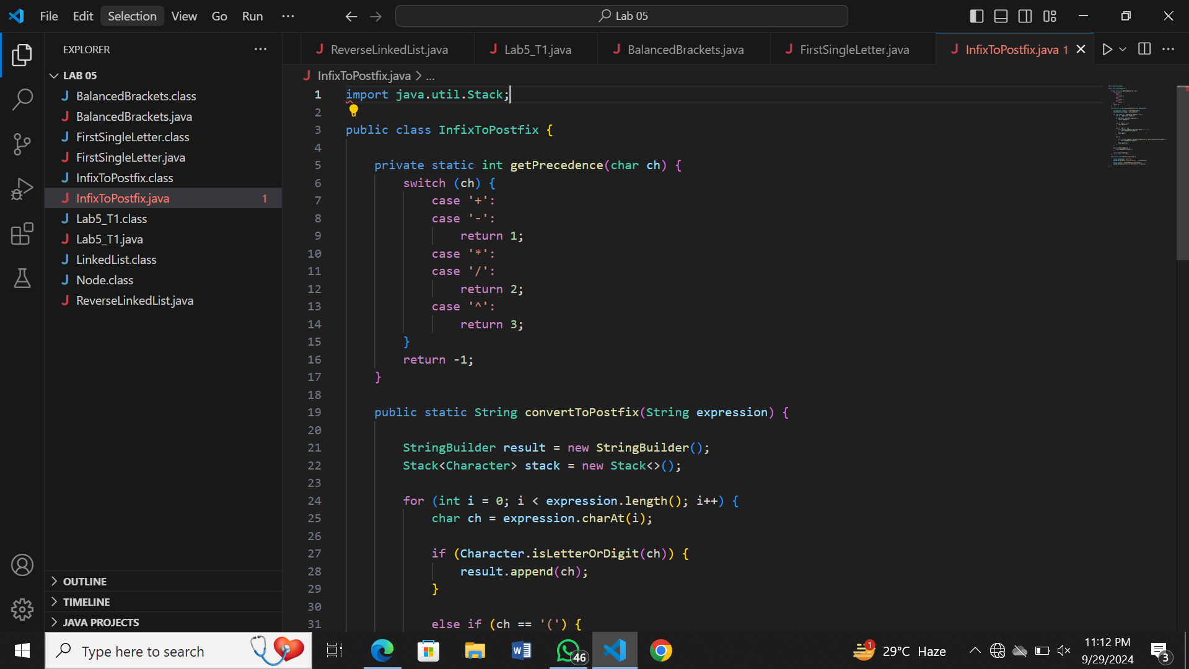

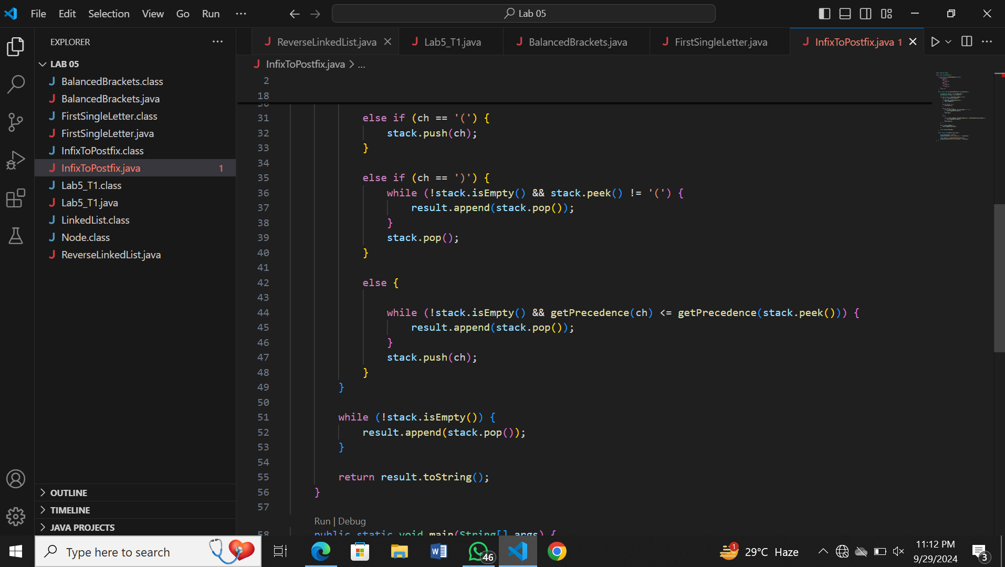

Output:

